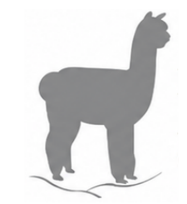 | PRECISION  FIBRE  ANALYSIS  SAMPLE SUBMISSION SHEET

Taryan 0419 386 068 | Max 0417 845 480 | precisionalpaca@gmail.com | precisionalpaca.com

1. CLIENT DETAILS
NAME

TRADING NAME / HERD PREFIX

ADDRESS

PHONE | EMAIL

2. TEST TYPE
☐ Standard Histogram  (Standard Midside) | ☐ Grid Histograms  (3-point grid sample) | ☐ Genetic Focus Analysis  (Midside) | ☐ Grid Genetic Focus Analysis  (3-point grid sample)
☐ Trim ON ☐ Trim OFF | ☐ Trim ON ☐ Trim OFF | NA | NA
NUMBER OF SAMPLES | NUMBER OF GRID SAMPLES | NUMBER OF SAMPLES | NUMBER OF GRID SAMPLES

*** If requiring different testing types in one submission, please package separately and provide a submission form per batch type.
3. GUIDE TO FIBRE SAMPLING
- Choose the same sample site on each alpaca. Use this site for each alpaca, for each year.
- The sample needs to be only the width of two fingers. Please ensure that the samples are free of seed, dirt and debris.
- Cut the sample as close to the skin as possible.
- Place sample in a paper bag (can be provided by Precision – email us for your free bags!) and write name/IAR etc on the bag.
- If sending for Genetic Focus testing, ensure to provide Precision with required alpaca details; Breed, Age (Years), Sex, Colour
- If sending grid samples, ensure each point is placed in its’ own bag and clearly labelled as shoulder, mid side, or rump. Preferable to staple the 3x bags together to ensure they stay together for testing.
- Send sample bags and Test Request form to: PO Box 1378, Kyneton, Victoria, 3444

